Curriculum Redesign:
New Paper Proposal

This proposal is for use only when it is accompanied by a Curriculum Redesign: Summary Proposal. When introducing just one or a small number of new papers use the standard New Paper Proposal.

Please retain the small font prompts for submission to the

Board of Undergraduate Studies and Board of Graduate Studies.

Subject Code, Number, Title
(60 characters maximum)
NZQA Level
Points Value
Year of Introduction

Content
(Provide a one-paragraph description of the proposed content for the new paper. Do not include a lecture schedule as this is not required.)

Prescription
(Refer to the Guide to Enrolment section on prescription information for format and a key to abbreviations. The description of the content should be no longer than 30 words. Include proposed subject code, paper number, points value and anticipated EFTS, prerequisites, restrictions, programmes the paper is ‘limited to’, whether it will offered on-campus (OC) and/or by distance learning (DL), and whether it is to be taught in First Semester, Second Semester, the Full Year period, Summer School or a Non-Standard teaching period. An exemplar is provided in the box as an example to follow. Your prescription may not need all of the lines below the description – the example is indicative only.)

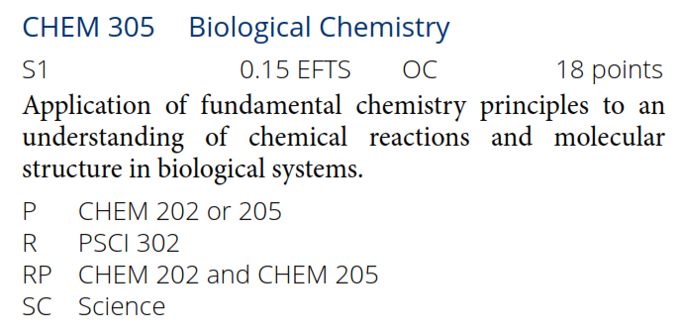

Occurrence Details
(Provide basic details of each occurrence of the paper, each listed separately. Include campus being taught at or from (Dunedin, Christchurch, Wellington, Invercargill, Auckland), teaching period (S1, S2, etc.), indicative start date (for each occurrence – if not standard), indicative end date (for each occurrence – if not standard), mode (i.e. on campus and/or distance learning). These details should be consistent with the paper’s prescription provided above.)

Campus Taught From | Teaching Period | Indicative Start Date (if Non- Standard) | Indicative End Date (if Non- Standard) | Mode  (i.e. on campus and/or distance learning) | Offered every year or in alternate years?

The teaching period of the paper being introduced has been considered in relation to existing papers that could be expected to be taken in combination with it.

Learning Outcomes (Aims/Objectives) of Paper
(Learning outcomes (aims/objectives) for individual papers can be described in a range of styles and should indicate what learners are able to do on successful completion of the paper. Outcomes for the paper should also contribute to the Graduate Profile of the programme – please identify which attributes of the Graduate Profile are achieved by the paper. For further information and generic Graduate Profile examples see the Teaching and Learning Plan and Graduate Profiles for University of Otago Postgraduate Research Degrees: http://www.otago.ac.nz/staff/ )

(The course design should ensure alignment between learning outcomes, teaching and learning methods, and assessment. When considering outcomes, be sure to consider the different domains such as knowledge, skills (generic and subject-specific) and attitudes. Note that assessment tasks in the next subsection will need to be aligned with the outcomes for the paper.)

# | Learning Outcome | Graduate Attribute(s)
1
2
3
4
5

(Delete or add lines as necessary.)

Assessment:
(In the table below, identify and describe the assessments that will be used in the paper. In designing the assessment, ensure you have read the University’s Guidelines for the Assessment of Student Performance. Indicate the contribution of each item of assessment towards the final grade and which paper learning outcome(s) it aligns with. A final examination worth 50% or less of the final grade would normally be two hours. A final examination worth more than 50% of the final grade is three hours. If the value of the final examination differs from these norms, please provide a brief justification beneath the table. If a minimum grade has to be achieved in the final examination to pass the paper as a whole, please state the minimum and provide a brief justification for the requirement. Also indicate if plussage will apply in the paper and provide a justification.)

Assessment Type  (e.g., essay, lab report, exam) | Description  (Include such details as word-length or duration) | Percentage | Learning Outcome(s)  #

(Delete unused lines or add lines for other activities as necessary.)

Formative Feedback:
(Describe how formative assessment will be used. Formative assessment is intended to help students to improve their learning and academic performance and typically has either no associated grade or a low point value. Feedback on formative assessments provides students with valuable information on their progress towards the learning outcomes. Examples of formative assessment and feedback are a draft essay outline with oral or written comments, and quizzes with constructive feedback about incorrect and correct responses.)

Student Workload Expectations
(The following table is designed to indicate the likely workload for the average student taking the proposed paper.

For undergraduate study 1 point = 10 hours (except for MB ChB, BDS, BPharm, and BPhty) (e.g. the expected student workload is 180 hours for an 18-point paper, 240 hours for a 24-point paper, and 360 hours for a 36-point paper).

For postgraduate study 1 point = 12 hours (e.g. expected student workload is 240 hours for a 20-point paper).

It is recognised that divisions may have guidelines for workload (total hours per point) for the undergraduate papers in their division. If this is the case please state any differences from the normal University expectation.)

Activity | Hours for Campus Students | Hours for Distance Students  (if applicable) | Derivation
Lectures |  |  | x per week for y weeks
Tutorials |  |  | frequency, duration, number of weeks
Laboratories |  |  | frequency, duration, number of weeks
In-class test
Non-contact hours
TOTAL HOURS
(e.g., 180, 240)

(Delete unused lines or add lines for other activities as necessary.)

Terms Requirements
(Some academic units require that a student gain terms before they sit final examinations (i.e. fulfil certain specified conditions, such as attending classes or completing oral, written and practical work to a satisfactory level). If students are required to gain terms before being permitted to sit the examination, please give details of these requirements. If there are no terms requirements, please state this.)

Internet-Based Learning
(Please indicate whether teaching and learning in the paper is available in part or as a whole via the Internet by stating which one of the four classifications it falls under.)

No Access is where no part of the paper or course is accessible online.
Web–Supported is where a paper or course expects students to access limited online materials and resources. Access is optional, as online participation is likely to be a minor component of study.
Web–Enhanced is where a paper or course expects students to access online materials and resources. Access is expected, as online participation is likely to make a major contribution to study.
Web–Based is where a paper or course requires students to access the accompanying online materials and resources. Access is required, as online participation is required.

