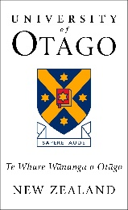
Department of Human Nutrition
Te Tari Kai Tōtika Takata
Spirit of Service and Community Engagement Prize

Application Form

Complete this form electronically and return by 4pm on the last Friday of Semester two to admin.humannutrition@otago.ac.nz
PART 1: STUDENT TO COMPLETE
Full Name  (as shown in eVision) |  | ID Number
Email address |  | Mobile number

Essay describing your community service, including a description of examples regarding how the engagement affected the community and how the experience affected your academic and personal development. (500 words maximum)

