Closing an Incident Investigation
When you are assigned an incident investigation an email will have been sent to you to notify that you have an incident to investigate.
The email will include a link which will take you to the incident.
You can also access the incident by logging into Vault/Damstra.
Select the Dashboard image/tab on the left of the screen then select My Assignments.
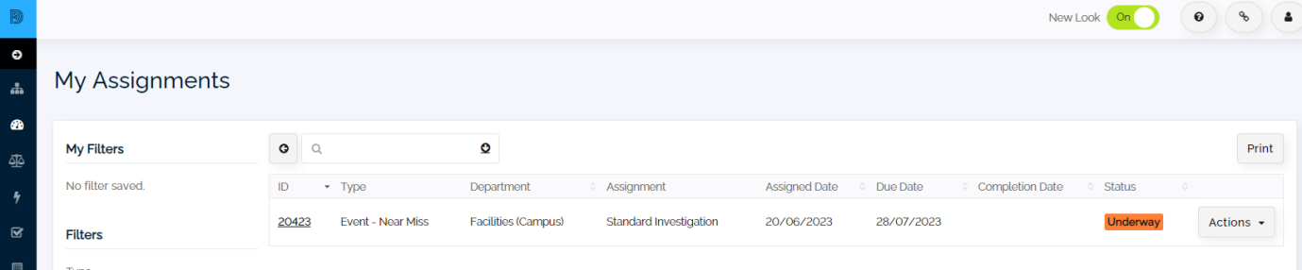

To make any adjustments to the “event’ select the Actions button at the right followed by Edit.
This will open the incident.
The location, description and person involved are located in the Event Details Tab. If you are happy with this page, you can complete the Event Status or change it to Underway using the drop-down menu. Note this does not complete the incident but is required. It must be marked completed upon completing the investigation.
Now select the Standard Investigation tab.
This is where you add your findings/investigation.
Upon completion of your investigation change the status to Completed. You will also need to ensure the completion date has been entered. Remember to also mark the status on the first page as completed.
At the bottom of the page is a Save to Events button. Save the changes you have made.

NB
If the Event has a Corrective Action included in the investigation, the report cannot be completed until the Corrective Action has been signed off.

